**Gas Leakage Monitoring & Alerting System For Industries**

|  |  |
| --- | --- |
| **Date** | 18 November 2022 |
| **Team ID** | PNT2022TMID06176 |
| **Project Name** | GAS LEAKAGE MONITORING AND ALERTING SYSTEM |
| **Batch Members** | Vishnu V  Gunaseelan D  Manojkumar S  Sanjai S |

**INDEX**

1. **INTRODUCTION**
   1. Project Overview
   2. Purpose
2. **LITERATURE SURVEY**
   1. Existing problem
   2. References
   3. Problem Statement Definition

1. **IDEATION & PROPOSED SOLUTION**
   1. Empathy Map Canvas
   2. Ideation & Brainstorming
   3. Proposed Solution
   4. Problem Solution fit
2. **REQUIREMENT ANALYSIS**
   1. Functional requirement
   2. Non-Functional requirements
3. **PROJECT DESIGN**
   1. Data Flow Diagrams
   2. Solution & Technical Architecture
   3. User Stories
4. **PROJECT PLANNING & SCHEDULING**
   1. Sprint Planning & Estimation
   2. Sprint Delivery Schedule
5. **CODING & SOLUTIONING (Explain the features added in the project along with code)**
   1. Feature 1
   2. Feature 2
   3. Database Schema (if Applicable)
6. **TESTING**
   1. Test Cases
   2. User Acceptance Testing
7. **RESULTS**
   1. Performance Metrics
8. **ADVANTAGES & DISADVANTAGES**
9. **CONCLUSION**
10. **FUTURE SCOPE**

**Abstract**

Leakage of any kind of gas has been a concern in recent years, whether it is in a residential setting, a business, a cafe, or a canteen. In this paper development of an IoT based gas wastage monitoring, leakage detecting and alerting system is proposed. This paper elaborates design such an intelligent system that will help save gas and smartly prevent accidents.

The system needs to be integrated with the cooker. The technology includes ultrasonic sensors that determine if the cooker is being utilized for cooking purposes or not. If it is discovered that the cooker is not in use, the system uses an automatic switching off mechanism to cut off the gas supply. The moment gas leakage will probably be recognized, users will be informed via SMS through GSM, and so that user can solve the issue as soon as possible.

The system will monitor flame and fire through flame sensor. When a fire is detected, the buzzer begins to sound. Aside from that, the system also has a cloud storage capability. The usage of gas for each user each day may be tracked with the aid of this cloud storage solution. At the end of the day, this procedure will assist in detecting per user natural gas usage.

The system has been tested and it is able to monitor gas wastage, leakage and send a SMS to the user. The resulting performance indicated its effectiveness toward saving a significant portion of the wasted gas in domestic.

**Introduction**

The usage of the gas brings great problems in the domestic as well as working places. The inflammable gas such as Liquidized petroleum gas (LPG), which is excessively used in the house and at work places. The leakage of the gas causes destructible impact to the lives and as well as to the heritage of the people.

So, by keeping it in the concept of the project we have determined to develop an examining system which finds the leak of LPG gas and protects the work places by taken correct precaution at correct time.

This system provides the information such as when a gas leakage is noticed, sensors of in the project are used to notice the gas leakage and immediately turns ON the buzzer for the danger indication.

Buzzer is a clear indication of gas leakage. By the detection of the hazardous gas the alerting message reached to the person who has control over it from the GSM. Detection of the gas leakage is important and halting leakage is important equally.

The main objective of this project is that it is extremely accurate with a least cost, this project system is best to detect gas leakage and also warn people around by buzzer beep sound and an SMS is been send to the responsible person for preparatory safety calculations.

**Project Overview**

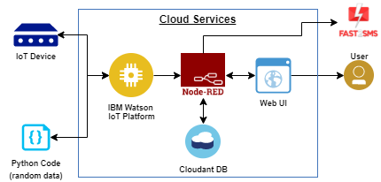

**Purpose**

The gas detectors can be used for the detection of combustible, flammable and poisonous gases and for loss of oxygen, and also to detected a gas leak or other pollutants. It makes the area where the leak occurs an warning sound and instructs operators to leave the area. The system proposed is planned, built and sent an SMS warning system for detection of gas leakages. Infrared imaging sensors have recently been used for a number of applications in industrial plants and refineries.

**Literature survey**

1. Existing problem

The placement of detectors should be determined through collaboration. This meeting of the minds includes the advice of experts with specialized knowledge of gas dispersion; experts with knowledge of the process plant system and equipment involved; and safety and engineering personnel. The agreement reached on the location of detectors also should be recorded.

Detectors should be mounted where the gas is most likely to be present. Locations requiring the most protection in an industrial plant or commercial building would be around gas boilers, compressors, pressurized storage tanks, cylinders or pipelines. Areas where leaks are most likely to occur include valves, gauges, flanges, T-joints and filling or draining connections.

1. Refrences

[1] Mahalingam, A., R. T. Naayagi, and N. E. Mastorakis. "Design and implementation of an economic gas leakage detector." Recent Researches in Applications of Electrical and Computer Engineering, pp. 20-24, 2012.

[2] Attia, Hussain A., and Halah Y. Ali. "Electronic Design of Liquefied Petroleum Gas Leakage Monitoring, Alarm, and Protection System Based on Discrete Components." International Journal of Applied Engineering Research, vol. 11, no. 19, pp. 9721-9726, 2016.

[3] Apeh, S. T., K. B. Erameh, and U. Iruansi. "Design and Development of Kitchen Gas Leakage Detection and Automatic Gas Shut off System." Journal of Emerging Trends in Engineering and Applied Sciences, vol. 5, no. 3, pp. 222-228, 2014.

[4] T.Soundarya, J.V. Anchitaalagammai, G. Deepa Priya, S.S. Karthick kumar, “C-Leakage: Cylinder LPG Gas Leakage Detection for Home Safety,” IOSR Journal of Electronics and Communication Engineering, vol. 9, no. 1, Ver. VI, pp. 53-58, Feb. 2014.

3.Problem statement definition

Liquid Petroleum Gas (LPG) is a highly flammable chemical that consists of mixture of propane and butane. LPG is used for cooking at home, restaurant, and certain use for industry. They have certain weaknesses that make the gas leakage occur.

The leakage of gases only can be detected by human nearby and if there are no human nearby, it cannot be detected. But sometimes it cannot be detected by human that has a low sense of smell.

Thus, this system will help to detect the presence of gas leakage.Further more, gas leakage can cause fire that will lead to serious injury or death and it also can destroy human properties. This system was developed by using IoT to give real-time response to the user and the nearest fire station.

**Ideation and proposed solution**

1.Empathy map canvas

Gas Leakage Monitoring And Alerting System For Industries

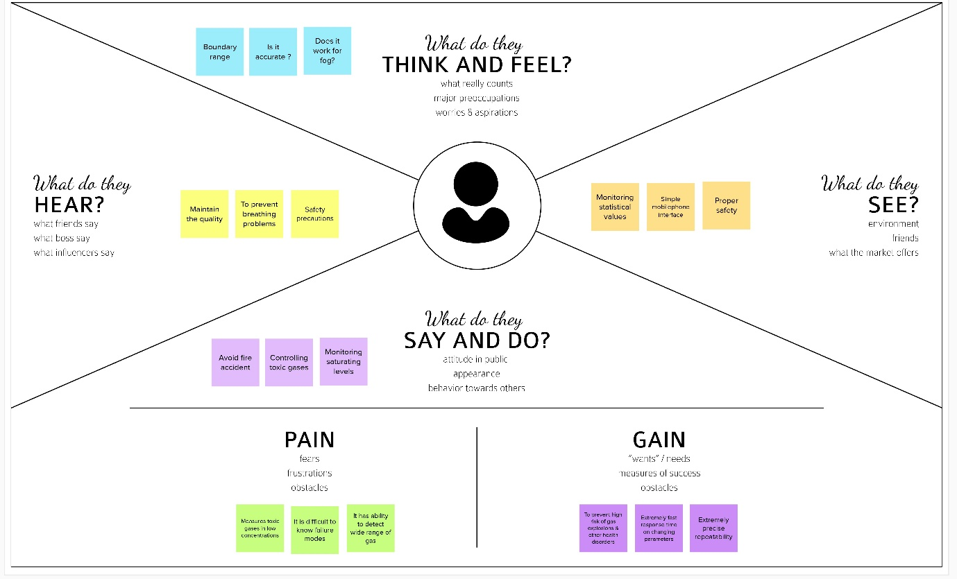

2.Brainstroming

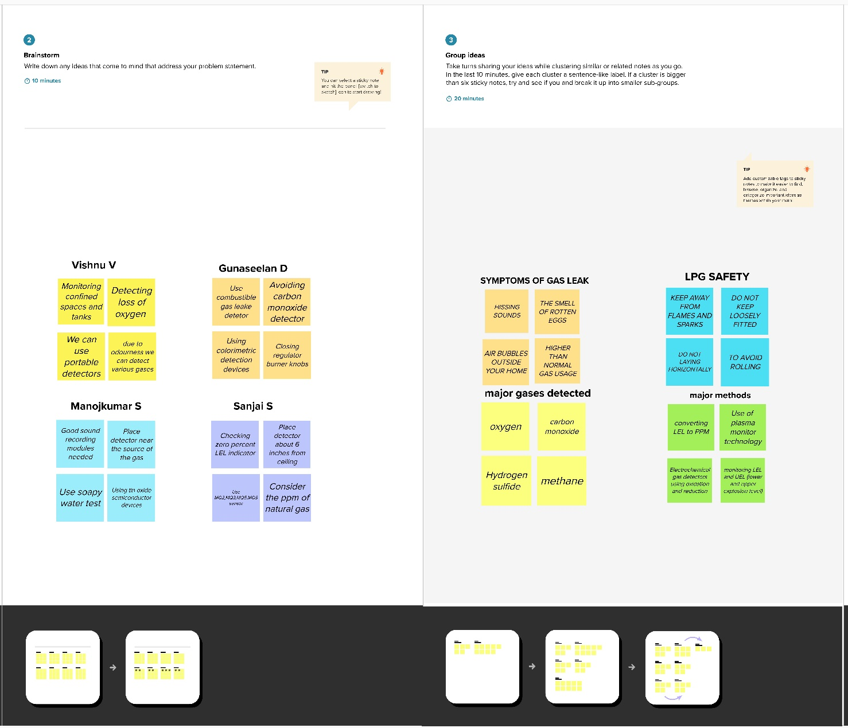

3.Proposed solution

|  |  |  |
| --- | --- | --- |
| S.No. | Parameter | Description |
| 1. | Problem Statement (Problem to be solved) | To reduce toxic gases which is measured in low concentration |
| 2. | Idea / Solution description | Toxic gas should be more than 200ppm but not more than 2000ppm by volume of gas |
| 3. | Novelty / Uniqueness | Using PPE(proper personal protection equipment) to prevent skin,eye,nose contact |
| 4. | Social Impact / Customer Satisfaction | Respiratory problems are prevented 5. Business Model (Revenue Model) Low cost and user friendly |
| 5. | Scalability of the Solution | accurate response time |

4.Problem solution fit

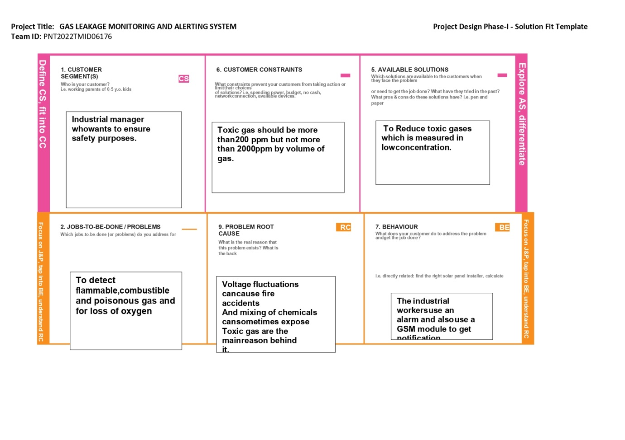

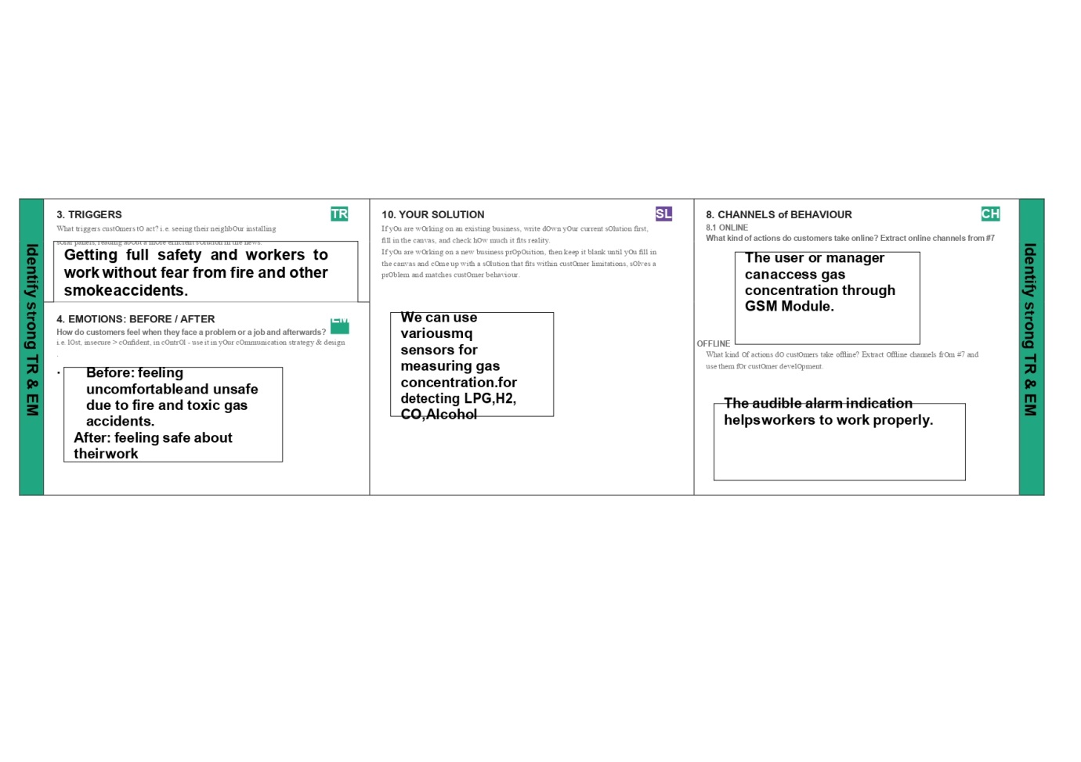

**Requirement analysis**

Functional requirements:

1. The user shall be able to receive warning message as quickly as possible.
2. The user shall be able to turn off the electricity.

3) The user shall be able to turn on the airrefreshing device.

4) The user shall be able to view information of fire station.

5) The user shall be able to view nearest fire station.

6) The user shall be able to navigate to nearest fire station.

7) The user shall be able to make call to 998.

8) The user shall be able to share his/her location.

Non-functional requirements:

Non-functional requirements "refer to behavioural properties that the system must have, such as performance and usability".

**Project design**

Data flow diagrams

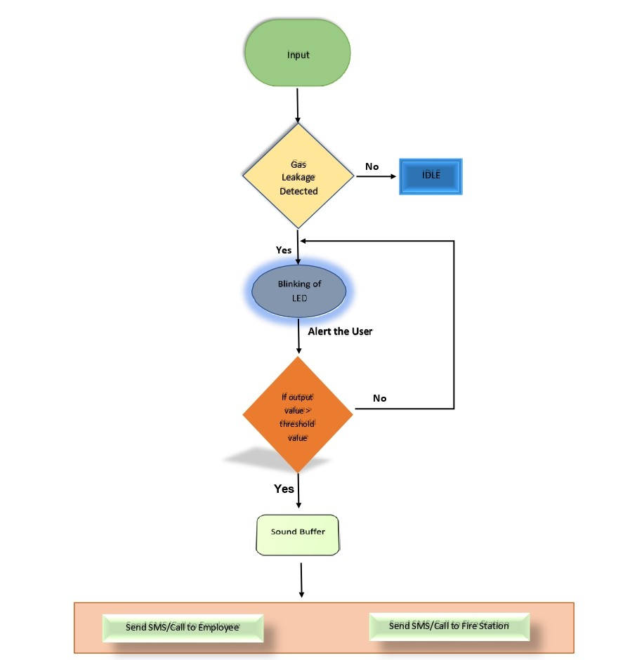

**User stories**

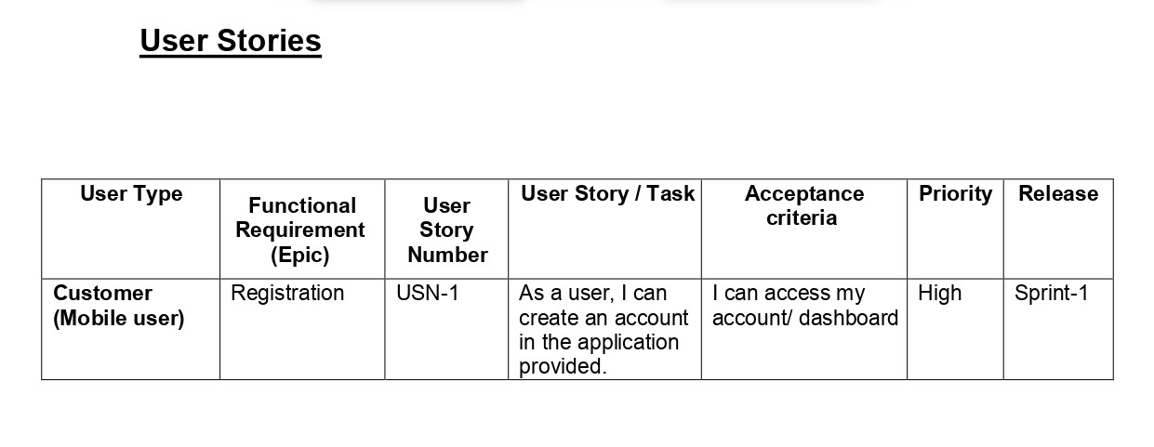

**Solution and Technical architecture**

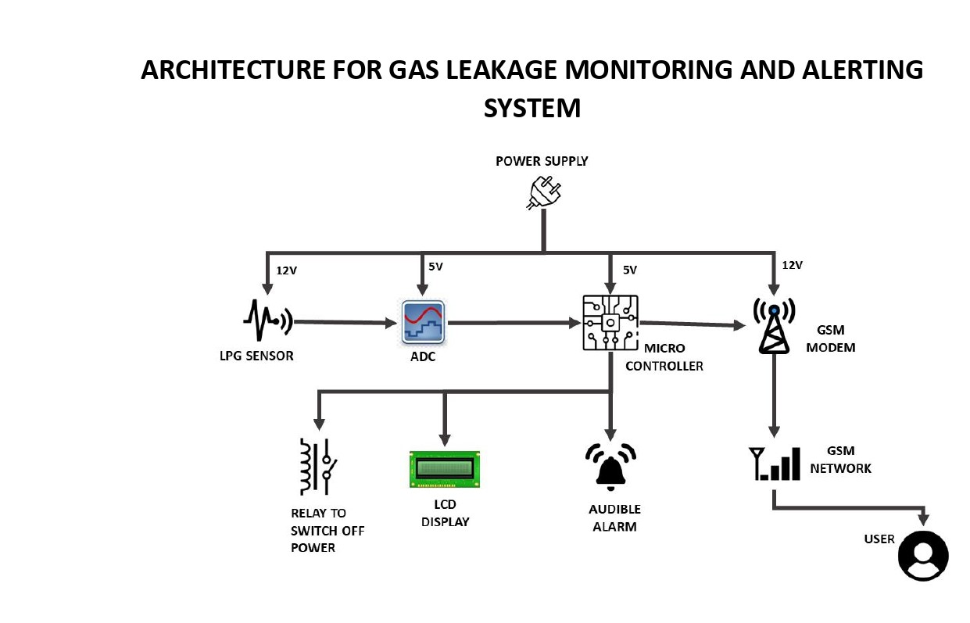

**Project planning and scheduling**

1.Sprint planning and estimation

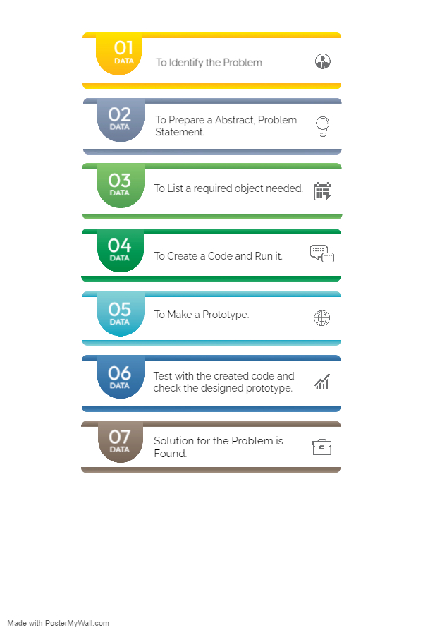

**Sprint delivery schedule**

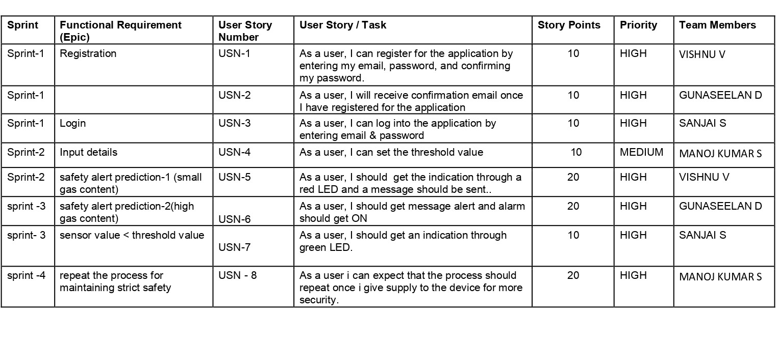

**Coding and solutioning**

#include <LiquidCrystal.h>

LiquidCrystal lcd(5,6,8,9,10,11);

//pin variables

int redled = 3;

int greenled = 2;

int buzzer = 4;

int sensor = A0;

int sensorThresh = 400;

void setup()

{

pinMode(redled,OUTPUT);

pinMode(greenled,OUTPUT);

pinMode(buzzer,OUTPUT);

pinMode(sensor,INPUT);

Serial.begin(9600);

lcd.begin(16,2);

}

void loop()

{

int analogValue = analogRead(sensor);

Serial.print(analogValue);

//gas concenteration condition

if(analogValue>sensorThresh)

{

digitalWrite(redled,HIGH);

digitalWrite(greenled,LOW);

tone(buzzer,1000,10000);

lcd.clear(); //to print on LCD

lcd.setCursor(0,1);

lcd.print("ALERT");

delay(1000);

lcd.clear();

lcd.setCursor(0,1);

lcd.print("EVACUATE");

delay(1000);

}

else

{

digitalWrite(greenled,HIGH);

digitalWrite(redled,LOW);

noTone(buzzer);

lcd.clear();

lcd.setCursor(0,1);

lcd.print("ALL CLEAR");

delay(1000);

}

**}**

**Problem Formulation**

Gas leakage is nothing but the leak of any gaseous molecule from a stove, or a pipeline, or cylinder etc. This can occur either purposefully or even unintendedly. As we are aware that these kinds of leaks are dangerous to our health, and when it becomes explosive it could cause great danger to the people, home, workplace, industry and the environment.

Few of the major incidents that took place due to gas leakage include the Bhopal Disaster and the Vizag Gasleak. The Bhopal disaster is known to be the worst industrial accident ever. Approximately 45 tons of Methyl Isocyanate was leaked from this insecticide plant. Methyl Isocyanate is an organic compound and a chemical that could come from the carbamate pesticides. This colorless, poisonous and flammable liquid is something that human beings have to be away from.

Vizag Gas leak was a resultant of the escape of styrene that were unattended for a long period. This colorless oily liquid can spread in fumes. So, a detector must be made in such a way that could detect any kind of gas, fume, leak, smoke etc. However harmful and dangerous it can be, the detector could be attached with certain parameters that could help to prevent the issue.

**List of Components**

|  |  |  |
| --- | --- | --- |
| **S. No** | **Name of the Component** | **Quantity** |
| 1 | Arduino UNO R3 | 1 |
| 2 | Breadboard | 1 |
| 3 | LED | 2 |
| 4 | Resistor | 5 |
| 5 | Piezo | 1 |
| 6 | Gas Sensor | 1 |
| 7 | LCD 16*2 | 1 |

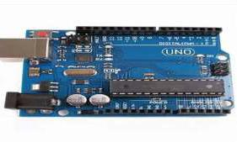**Arduino UNO R3**

Arduino Uno R3 is one kind of ATmega328P based microcontroller board. It includes the whole thing required to hold up the microcontroller; just attach it to a PC with the help of a USB cable, and give the supply using AC-DC adapter or a battery to get started. The term Uno means “one” in the language of “Italian” and was selected for marking the release of Arduino’s IDE 1.0 software. The R3 Arduino Uno is the 3rd as well as most recent modification of the Arduino Uno. Arduino board and IDE software are the reference versions of Arduino and currently progressed to new releases. The Uno-board is the primary in a sequence of USB-Arduino Board, & the reference model designed for the Arduino platform

.

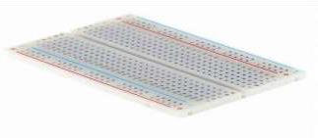**Breadboard**

A breadboard is a widely used tool to design and test circuit.

You do not need to solder wires and components to make a circuit while using a bread board. It is easier to mount components & reuse them. Since, components are not soldered you can change your circuit design at any point without any hassle. It consist of an array of conductive metal clips encased in a box made of white ABS plastic, where each clip is insulated with another clips. There are a number of holes on the plastic box, arranged in a particular fashion. A typical bread board layout consists of two types of region also called strips. Bus strips and socket strips. Bus strips are usually used to provide power supply to the circuit. It consists of two columns, one for power voltage and other for ground. Socket strips are used to hold most of the components in a circuit. Generally it consists of two sections each with 5 rows and 64 columns. Every column is electrically connected from inside.

**LED**

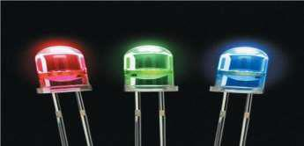

LED (Light Emitting Diode) is an optoelectronic device which works on the principle of electro-luminance. Electro-luminance is the property of the material to convert electrical energy into light energy and later it radiates this light energy. In the same way, the semiconductor in LED emits light under the influence of electric field. The symbol of LED is formed by merging the symbol of P-N Junction diode and outward arrows. These outward arrows symbolise the light radiated by the light emitting diode.

**Resistor**

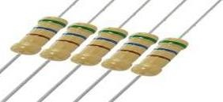

A passive electrical component with two terminals that are used for either limiting or regulating the flow of electric current in electrical circuits.

**Piezo**

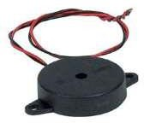

A piezo is a device that generates a voltage when force is applied or becomes deformed when voltage is supplied.

**Gas Sensor**

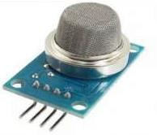 A gas sensor is a device which detects the presence or concentration of gases in the atmosphere. Based on the concentration of the gas the sensor produces a corresponding potential difference by changing the resistance of the material inside the sensor, which can be measured as output voltage. Based on this voltage value the type and concentration of the gas can be estimated.

**LCD 16*2**

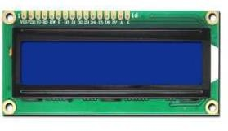

16×2 LCD is one kind of electronic device used to display the message and data. The term LCD full form is Liquid Crystal Display. The display is named 16×2 LCD because it has 16 Columns and 2 Rows. it can be displayed (16×2=32) 32 characters in total and each character will be made of 5×8 Pixel Dots. These displays are mainly based on multi-segment light emitting diodes. There are a lot of combinations of display available in the market like 8×1, 8×2, 10×2, 16×1, etc. but the 16×2 LCD is widely used. These LCD modules are low cost, and programmer-friendly, therefore, is used in various DIY circuits, devices, and embedded projects.

**Testing**

LPG leakage detection system helps in our security and make our home and kitchen safe. This system can detect easily the gas in the surrounding.

When LPG gas leakage sensed, it will give a HIGH pulse on its DO pin and Arduino constantly reads its DO pin. When Arduino receives a HIGH pulse from the LPG Gas sensor module it displays the“ Alert” message on 16x2 LCD and stimulates buzzer.

which beeps again until the gas detector module doesn't recognize the gas in the environment and red led in on. When gas is not there in the surroundings it will display "ALL CLEAR" in the LCD and green led will be on.

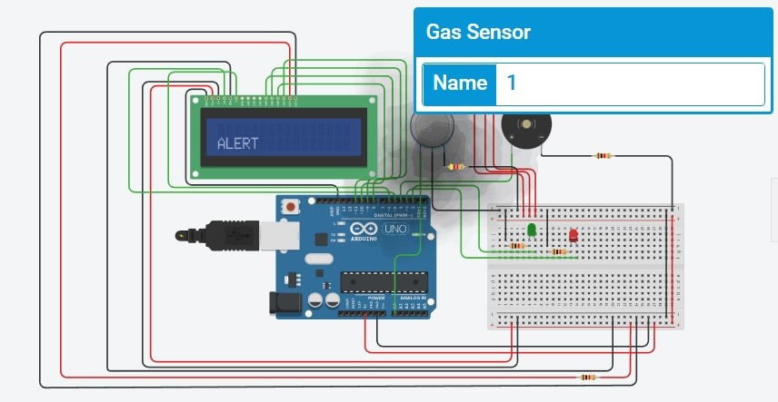

**Advantages and disadvantages of portable and fixed gas detector:**

1. [portable gas detector](https://www.ocgasdetector.com/en/Portable-gas-detector-.html): as a portable instrument convenient operation, small size, with built-in sampling pump, detection quickly, high precision, can be carried to different places, the boot can be used.

As a kind of instrument in all kinds of factories and the application of the environmental protection department is more and more widely. But the instrument needs to be charged, not long time detection.

2. [fixed gas detector](https://www.ocgasdetector.com/en/Fixed-gas-detector.html): can be installed at a specific point of detection for a specific gas leak for 24 hours of continuous detection. This is in the industrial device and the production process using more testing.

But the instrument needs to be connected to the power supply to work, not easy to move, and the use of the environment (pressure, temperature and humidity) requires a higher.

**Conclusion**

Most of LPG explosions are caused by undetected gas leakage in the pre-detection condition. So that, LPG detection system is needed. The purpose of this system is to detect gas leakage, neutralize it, and prevent the explosion.

Gas leakage could happen due to improper regulator installation or the hose is broken. This detection should not work in just one location because gas can leak at the gas regulator and its hose. Therefore, Wireless Sensor Network (WSN) is one of the methods that suitable for detecting gas leakage in the wider area.

This method uses two or more gas sensors to detect leakage in two or more locations around the gas tube and its distribution line. WSN system works based on gas sensor MQ-6 and wireless module Bluetooth HC-05. Explosion prevention system works based on alarm/buzzer, exhaust fan, and automatic gas regulator. If the gas leaks, the sensor will send its data wirelessly to Arduino.

Then, explosion prevention system will be activated. The system will turn the alarm/buzzer on, automatically releases gas regulator, and neutralizes the air with the exhaust fan. Both systems will be fully controlled by Arduino platform.

**Future scope**

Major cities of India are pushing Smart Home application, gas monitoring system is a part of Smart Home application. Enhancing Industrial Safety using IoT. IoT turns drone into gas detection sensor. Another major future scope could be including a Automatic Shut-off device which will turn off the gas supply whenever it will detect any gas leakage.

This system can be implemented in Industries, Hotels and wherever the LPG cylinders are used. This system can be used in industries involving applications such as Furnace, Boilers, Gas welding, Gas cutting, Steel Plants, Metallurgical industries, Food processing Industries, Glass Industries, Plastic industries, Pharmaceuticals, Aerosol manufacturing. As hospitals require to provide maximum possible safety to patients, this system can be used to keep track of all the cylinders used in it. Some of the cylinders used are Oxygen cylinder, Carbon dioxide cylinder, Nitrous oxide cylinder. As many students are naïve the risk of causing accidents is high. Hence, our system can also be used in schools, colleges. Many colleges have well established labs including chemistry lab and pharmaceutical labs where gas burners are used. Plenty of medical equipment requires gas cylinders.

**Appendix**

[**https://youtu.be/YIaCLUfgk0k**](https://youtu.be/YIaCLUfgk0k)

[**https://youtu.be/rhhgcuME8GM**](https://youtu.be/rhhgcuME8GM)